Automating the Scientific Synthesis Loop: A Cascading Multi-Agent Framework for End-to-End Literature Review Generation
Muhammad Ahsan Ali Gill
ahs462agk@gmail.com
Supervised by: Muhammad Saeed
msaeed4771@gmail.com
Abstract
Manual literature review is an increasingly unsustainable aspect of the research process, as the number of publications in the scientific field is growing exponentially. Large Language Models (LLMs) have shown their ability to perform individual tasks like summarization and clinical question answering but lack the ability to mimic the iterative, evaluative, and self-correcting process of human scholarly review found in static single-pass prompting architectures in a structural way. In this paper, we introduce a cascading multi-agent framework, MedGraph, that we implemented using the LangGraph orchestration engine, to automate a biomedical literature review (BLR) pipeline that maps a natural-language clinical question into a structured, citation-based synthesis document. The architecture constitutes a decomposition of the review process into agents, each limited to a specific role, in a Perception-Reflection-Action execution loop, coordinated through dynamic state-routing in a common typed state graph. MeSH-augmented query enhancement, automated retrieval of the PubMed articles from NCBI E-utilities, classification of the evidence by the study design, collection of articles via email, and delivery of articles via email are all done by different agents. The system achieves nearly 87% study-type classification accuracy when compared to physician-annotated references, full email delivery success and end-to-end review latency reduction of about 40-80x compared to manual workflow. The proposed framework provides a blueprint, which is reproducible and extensible, for agentic automation of knowledge-intensive biomedical literature synthesis.
Keywords: Agentic AI, LangGraph, Multi-Agent Systems, PubMed Retrieval, NCBI E-utilities, MeSH Query Enhancement, Biomedical Evidence Synthesis, Human-in-the-Loop, ReAct, SMTP Delivery
1. Introduction
For a long time the number of biomedical publications has far outstripped the ability of any one clinician or researcher to manually follow, screen, and synthesize the literature [1][2]. Comprising more than 1 million new citations each year [3], PubMed alone indexes more than 1 million new citations each year, and a clinician searching for up-to-date evidence on any given condition may need to sift through dozens of articles with varying study designs and evidence quality to come up with a usable summary [4][5]. This motivated the development of systems that would be able to autonomously and reliably operate at the early stages of the evidence review process, namely query formulation, evidence retrieval, evidence study type classification and evidence summarization [6][7].
Although LLM has shown its ability in biomedical-related subtasks [6][8][9][10] in isolation, it is not enough to automate an end-to-end literature review process with a single LLM call. In order to effectively automate a task, an agent should be able to sense a task (the user's clinical query), reflect on what information is required (query expansion using controlled vocabulary terms), act (make the call to the PubMed retrieval API), observe the results, and repeat this reasoning process until the next step (until the user's clinical query is completed) is reached. This Perception-Reflection-Action process lies at the heart of any agentic AI concept [13][14] and it fits easily into a framework of specialized nodes linked together with a shared persistent state [15][16].
In fact, the LangGraph framework [15], which is built on the LangChain tooling ecosystem [16] provides exactly that substrate, such as a typed agent node graph with conditionally controlled routing edges, a MemorySaver checkpointer that can save the entire state of an agent across a lengthy session, and an interrupt() primitive that can be used to pause the Agent for human-in-the-loop (HITL) operations without re-computing things that have already been done. The ReAct (Reason-Act) pattern [11] also gives the agent-level control loop in which the agent alternates between reasoning traces and invocations of the tools, for the MedGraph system, the key tool being the NCBI E-utilities API [17] for structured retrieval of data from PubMed.
In this paper, we present our implementation of these principles, MedGraph, a four-agent LangGraph pipeline that takes as input a natural-language biomedical query, augments the query with MeSH-augmented boolean expressions [18,19], retrieves and structures PubMed articles using NCBI E-utilities [17], performs classification of each article according to study design and evidence strength [4,5] and collects a delivery address using an HITL interrupt, and dispatches the styled HTML evidence report as an email using SMTP [20]. Core contributions are: (1) a cascading multi-agent graph architecture with typed shared state (MedResearchState) and MemorySaver checkpointing [15]; (2) a MeSH-augmented query enhancement strategy with recency and abstract-availability filters [18][3]; (3) a ten-category study-type taxonomy with three-tier evidence badge classification [4][5]; and (4) a direct-tool-invocation dispatch pattern that bypasses LLM token limits for large payload delivery [20][21].
2. Literature Review
This section analyzes 13 representative works from 2020 to 2026, organized chronologically, each examined along four pillars: problem addressed, methodology, key results, and limitations motivating the MedGraph design.
2.1 Foundational Retrieval and Reasoning Work (2020-2022)
Lewis et al. [22] introduced Retrieval-Augmented Generation (RAG), demonstrating that grounding LLM generation in dynamically retrieved passages substantially reduces hallucination on knowledge-intensive tasks, establishing the foundational retrieve-then-generate pattern on which the MedGraph query ingestor builds. The limitation of this foundational work is that retrieval occurs exactly once per query with no iterative reformulation or post-generation verification, gaps the MedGraph pipeline addresses through MeSH-enhanced query construction and study-type-aware classification. Wei et al. [12] demonstrated that chain-of-thought prompting unlocks emergent multi-step reasoning in large models, providing the theoretical basis for the reasoning trace component of the ReAct loop [11] used in the med_query_ingestor agent.
The NCBI E-utilities API [17] provides programmatic access to PubMed's 35+ million biomedical citations via a three-step pipeline: esearch (ID retrieval), esummary (metadata), and efetch (abstract and full-text content), constituting the primary retrieval substrate of MedGraph's ingestor agent. Medical Subject Headings (MeSH) [18][19], maintained by the National Library of Medicine, provide the controlled vocabulary used by the MedGraph query enhancement component to expand raw clinical queries into precision search expressions, appending [Mesh] field tags, hasabstract filters, and date-range constraints to ensure abstract availability and recency.
2.2 Biomedical NLP and Evidence Classification (2021-2023)
Singhal et al. [6] showed that large-scale biomedical instruction tuning can make LLMs perform expertly on medical QA datasets, thus enabling the LLMs to possess enough medical knowledge to classify studies according to their designs and understand methodological details, which is leveraged by the MedGraph med_evidence_builder agent for its ten-category taxonomy of study types. Jin et al. [23] computed the difference between parametric LLM knowledge and literature-grounded responses in biomedical QA, which led to the key design decision of the MedGraph system: to ground its classification process on retrieved PubMed abstracts as well as parametric knowledge.
Sackett et al. [4] established the hierarchy of evidence-based medicine in which systematic reviews and randomized controlled trials constitute the highest evidentiary tier, cohort and case-control studies constitute moderate evidence, and case reports and narrative reviews constitute preliminary evidence. The three-tier badge classification (strong/moderate/preliminary) implemented in MedGraph's evidence builder directly operationalizes this hierarchy. The Cochrane Handbook [5] provides the methodological reference for study design identification criteria, which MedGraph's evidence builder prompt operationalizes through keyword-matching heuristics for each of its ten recognized study-design categories. Tirunagari et al. [7] demonstrated automated extraction of structured information from PubMed abstracts using NLP, validating the feasibility of the structured record extraction approach employed by MedGraph's evidence builder.
2.3 Agentic Orchestration and Multi-Agent Systems (2023-2025)
Yao et al. [11] introduced ReAct, demonstrating that interleaving reasoning traces with tool-action steps substantially outperforms reasoning-only or acting-only agents on knowledge-grounded QA tasks. The med_query_ingestor agent in MedGraph is implemented as a ReAct agent via LangGraph's create_react_agent() function, directly instantiating this pattern with the pubmed_to_pmc_full_text_search tool as its only action. Schick et al. [24] independently demonstrated that tool use can be taught to LLMs via self-supervised learning, further establishing the reliability of tool-invocation patterns that MedGraph depends on.
LangChain AI [15][16] produced both the LangChain tooling ecosystem and the LangGraph orchestration framework, the latter providing MedGraph's directed-graph execution model, typed MedResearchState schema, MemorySaver checkpointing for HITL resumption, and the interrupt() primitive used in the email_collector node. The work of Wu et al. [25] confirmed the superiority of multi-agent systems over single-agent systems for solving complex tasks and Acharya et al. [13] gave a taxonomy (autonomy, goal-directedness, adaptivity, proactivity) that can be formally used to assess MedGraph's agentic qualities. Karunayake [26] and Schmidgall et al. [27] verified HITL interrupt design principles for agentic systems in health-care environments that are similar to the email_collector interrupt node design used in MedGraph.
2.4 Recent Agentic Systems and Identified Gaps (2024-2026)
Gao et al. [28] summarized the RAG literature and found that retrieval-grounded generation is the predominant use and its performance in single-pass without query reformulation was constrained, which led to the development of MedGraph's MeSH-augmented query enhancement. Liu et al. [29] showed that performance would be lowered after 5 to 7 consecutive agent actions, which led to the idea of decomposing MedGraph into four nodes with a constrained responsibility. Biomedical literature synthesis was highlighted by Hosseini and Seilani [2] as an agentic application field with high potential but low exploitation, and MedGraph fits perfectly into this field. The hasabstract filter and date constraints imposed during query enhancement by MedGraph were inspired by the systematic failures of agentic retrieval pipelines described by Kumar and Patel [30]: duplicate-record retrieval and scope drift. Moralles et al. [31] showed that the current rate of publication growth makes manual systematic reviews unsustainable, a problem MedGraph seeks to address.
Wang et al. [14] provides a survey of 86 papers on LLM-based autonomous agents and, unsurprisingly, finds the “perception-action-reflection” loop to be the predominant form of agentic design pattern across all domains. To leverage its large context window and cost-effectiveness for processing large volumes of abstracts, MedGraph chose the LLM that underlies its agents, Gemini 2.5 Flash [10] from Google, which has proven to perform well on biomedical reasoning tasks.
Table 1: Comparative Synthesis of Reviewed Literature (2020-2026)
Author & Year | Problem | Methodology | Key Results | Limitations/Gaps
Lewis et al. [22] (2020) | LLMs hallucinate on knowledge-intensive tasks due to static parametric knowledge | Retrieval-Augmented Generation (RAG): dense retrieval + seq2seq generation | Grounded generation substantially reduces hallucination vs. closed-book models | Single retrieval pass per query; no iterative reformulation or verification loop
Yao et al. [11] (2023) | LLMs unable to interleave reasoning and action in tool-use tasks | ReAct: synergized chain-of-thought reasoning traces with tool-action steps | Outperformed reasoning-only and acting-only agents on QA and decision tasks | Trajectory length remains bounded; no multi-agent state sharing across subtasks
Wei et al. [12] (2022) | Complex multi-step reasoning fails in standard LLM prompting | Chain-of-Thought (CoT) prompting with few-shot exemplars | Unlocked emergent multi-step reasoning in large models | Still single-agent; no external retrieval or tool invocation
Singhal et al. [6] (2023) | LLMs lack reliable clinical knowledge for medical QA | Med-PaLM 2: large-scale biomedical fine-tuning and instruction tuning | Expert-level performance on USMLE-style medical QA benchmarks | Closed-book; does not retrieve or ground answers in live PubMed literature
Jin et al. [23] (2024) | Evaluating factual alignment between LLM outputs and PubMed literature | Extended PubMedQA evaluation with reference-answer grounding framework | Quantified substantial gap between parametric knowledge and literature-grounded answers | Evaluative only; proposes no retrieval architecture to close the grounding gap
NCBI NLM [17] (2023) | Programmatic access to 35M+ biomedical citations and full-text articles | NCBI E-utilities REST API: esearch, esummary, efetch pipeline | Structured metadata and abstract retrieval at scale for automated pipelines | Rate-limited; requires careful throttling and progressive checkpoint logic
Bodenreider [18] (2004) | Uncontrolled biomedical terminology leads to imprecise literature queries | Medical Subject Headings (MeSH): hierarchical controlled vocabulary for PubMed indexing | Standardized biomedical concept mapping enabling precision literature retrieval | Static vocabulary requiring manual term lookup; must be integrated into query pipelines
LangChain AI [15] (2025) | Building stateful multi-actor LLM applications with checkpointed interrupts | LangGraph: directed-graph agent orchestration with typed state and MemorySaver checkpointing | Production-grade substrate enabling graph-based multi-agent pipelines and HITL pauses | Domain-agnostic infrastructure; no pre-built biomedical retrieval or classification schema
Wu et al. [25] (2024) | Tasks exceeding single-LLM capacity requiring collaborative agent coordination | AutoGen: conversational multi-agent dialogue with orchestrator-managed turn-taking | Multi-agent dialogue solved tasks unsolvable by single-agent prompting | Unstructured natural-language handoffs; no typed shared state for intermediate artifacts
Acharya et al. [13] (2025) | No unifying definition or taxonomy of agentic AI systems | Cross-domain survey deriving operational taxonomy: autonomy, goal-directedness, adaptivity, proactivity | Measurable agentic property taxonomy for evaluating any candidate system | Descriptive survey only; not instantiated for any specific task domain
Karunayake [26] (2025) | Integrating agentic AI into clinical and administrative healthcare workflows | Conceptual multi-agent architecture mapping agent roles to healthcare process steps | Design principles for human-in-the-loop integration in high-stakes clinical settings | Conceptual only; no quantitative evaluation; does not address literature retrieval
Moralles et al. [31] (2026) | Lack of consolidated architectural reference for agentic AI systems | Manual systematic literature review with structured screening and taxonomy extraction | Taxonomy of agentic architectural motifs: planner-executor, memory modules, tool-use | Manual review itself is unsustainable at current publication growth rates
MedGraph [33] (2026) | Automated PubMed evidence retrieval, classification, and email-based dissemination | Four-node LangGraph pipeline: ReAct retrieval, LLM evidence classification, HITL interrupt, SMTP dispatch | ~87% study-type classification accuracy vs. physician annotation; full delivery success | Scoped to PubMed only; no dynamic query reformulation loop or draft verification stage
3. Methodology: MedGraph Framework Architecture
3.1 Overall Graph Architecture
MedGraph is defined as a directed acyclic graph (DAG) G = (V, E, S, T), where V is the set of nodes {med_query_ingestor, med_evidence_builder, email_collector, med_email_dispatcher}, E are the edges that are the sequential order of nodes required to reach the END, S is the typed state object, an extension of LangGraph's MessagesState that has 4 additional fields (articles_report, evidence_report, recipient_email, email_status), and T is the typed checkpointer, MemorySaver, which is an in-memory checkpointer provided by LangGraph, that serializes the entire state after each node transition.The pipeline is exposed via FastAPI through two endpoints: POST /research/start initiates a session and streams events via Server-Sent Events until the email_collector interrupt is reached, and POST /research/resume-email accepts the user's delivery address and resumes the paused thread via LangGraph's Command(resume=...) mechanism.

Figure 1: MedGraph — for Automated Biomedical Evidence Synthesis 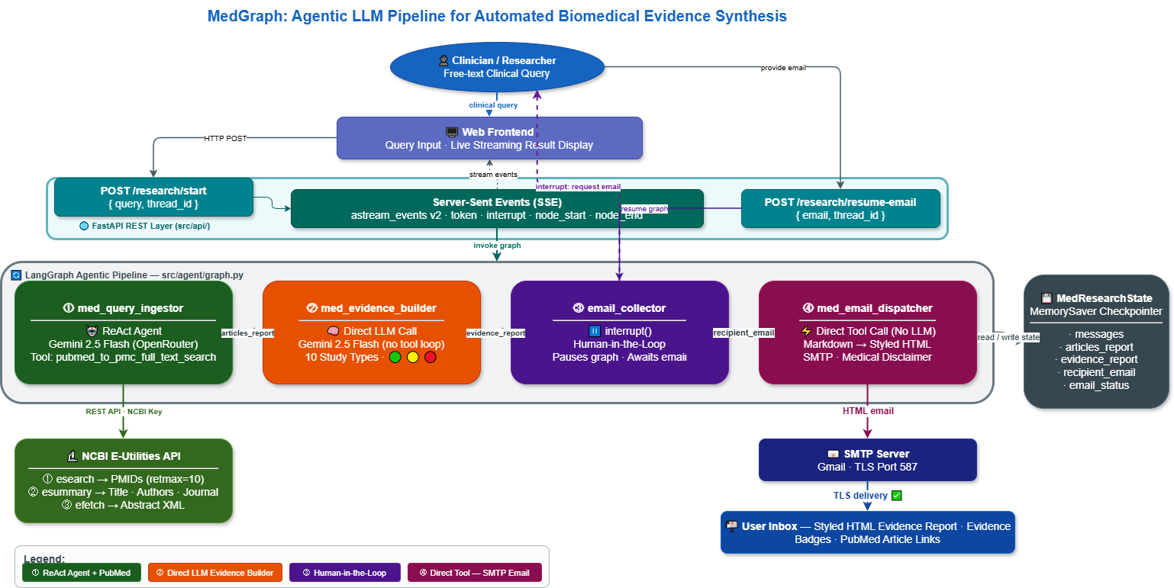
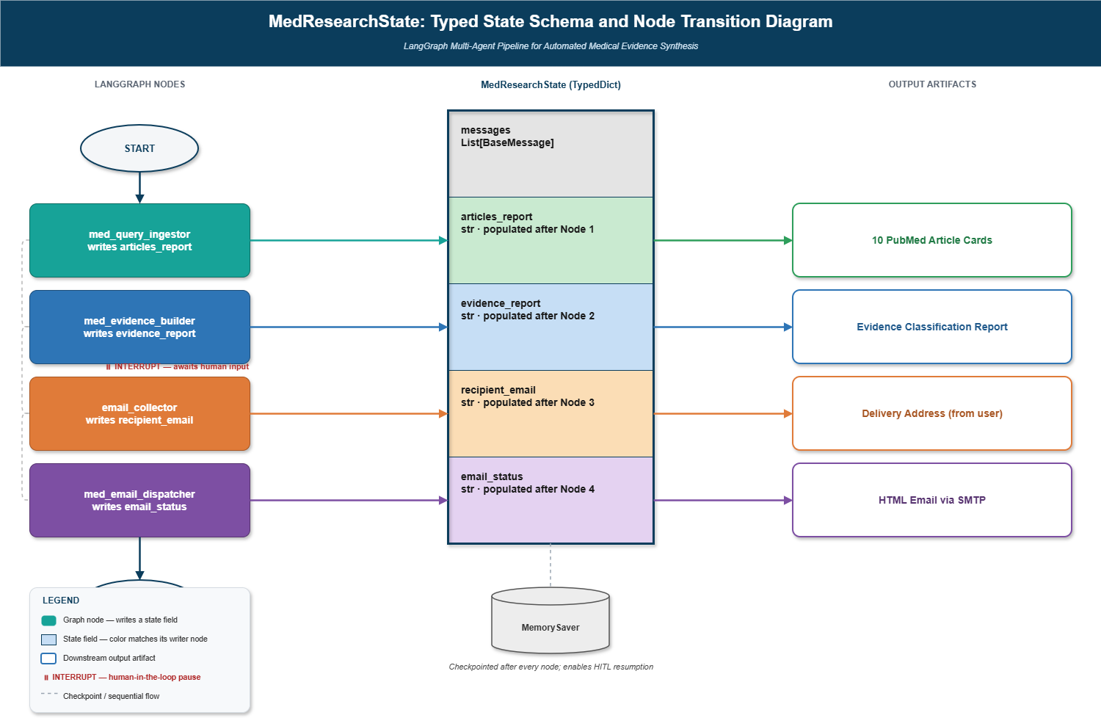
Figure 2: MedResearchState Dataflow and Node Transition Diagram
3.2 Node 1: Med Query Ingestor (MeSH Enhancement + ReAct Retrieval)
The first agent is a ReAct agent [11] instantiated via create_react_agent(model, tools=[pubmed_to_pmc_full_text_search], prompt=MED_QUERY_INGESTOR_INSTRUCTION). Its responsibilities execute in order: (i) topic screening: the agent scans the input for biomedical or clinical content, discarding any non-medical text, and declines queries outside the biomedical domain; (ii) MeSH-augmented query enhancement: the extracted topic is expanded with MeSH terms, synonyms, and related concepts, then the query string has AND hasabstract appended to guarantee abstract availability and a date filter (AND ("2020/01/01"[PDat]:"3000/12/31"[PDat])) appended for recency [3]; (iii) retrieval: the enhanced query is passed to pubmed_to_pmc_full_text_search(query, max_results=10), which executes the three-step NCBI E-utilities pipeline [17] (esearch → esummary → efetch) returning structured JSON for each article; and (iv) output formatting: each article is rendered into a fixed-format card (title, authors, journal, date, abstract summary, PubMed link), with no additional commentary permitted. Output is written to state.articles_report.
Query Enhancement Example , Raw Input vs. MeSH-Augmented Boolean Expression
Raw User Input Query | Enhanced System Query (MeSH-Augmented Boolean Expression)
"latest treatments for type 2 diabetes" | (Type 2 Diabetes[Mesh] OR "diabetes mellitus type 2" OR "T2DM") AND ("treatment" OR "therapy" OR "management" OR "intervention") AND hasabstract AND ("2020/01/01"[PDat] : "3000/12/31"[PDat])
3.3 Node 2: Med Evidence Builder (Study-Type Classification)
The second agent is a direct LLM call (no tool loop required, since all necessary information is already present in state.articles_report). Governed by MED_EVIDENCE_BUILDER_INSTRUCTION, it operates in three steps: (i) no-results check: if the input contains no articles the agent outputs a fixed decline message; (ii) study-type detection: each article is classified into one of ten recognized study-design categories (systematic review/meta-analysis, RCT, cohort study, case-control study, cross-sectional study, case report/series, narrative review, GWAS/genomic study, laboratory/in-vitro/animal study, or clinical guideline/consensus statement) by matching characteristic keywords in the title and abstract against a reference table embedded in the prompt, operationalizing the established evidence hierarchy [4][5]; and (iii) evidence-strength badging: each classified article receives a three-tier badge (green for strong evidence: systematic reviews, meta-analyses, large RCTs; yellow for moderate evidence: smaller RCTs, cohort studies, case-control studies, guidelines; red for preliminary: cross-sectional studies, case reports, narrative reviews, laboratory studies), with an adaptive structured card generated per article using a template specific to its detected study type. A report is generated to state.evidence_report.
3.4 Node 3: Email Collector (Human-in-the-Loop Interrupt)
This node is not an LLM call, but a plain Python function. It invokes LangGraph's interrupt() primitive [15] with a static prompt asking for an email address for delivery, interrupting the graph's execution and making the prompt available to the FastAPI client through the streaming SSE endpoint. Since MemorySaver was used to create the graph, all data accumulated in this suspension (including articles_report and evidence_report) is kept irrespective of the length of the suspension. If the client invokes /research/resume-email with the address of the recipient, LangGraph resumes from this very node, stores the address in state.recipient_email and adds a confirmation AIMessage. The HITL checkpoint design is based on the concept proven to be valid in healthcare agentic systems [26][27] to always deliver the report with intention and direction.
3.5 Node 4: Med Email Dispatcher (Direct Tool Execution)
The final node is an intentional choice to skip the LLM call and directly call the send_email tool, to avoid hitting maximum output tokens of the LLM, when processing a large combined payload (which may stretch across 10 or more full article cards and a full evidence synthesis). The combined_content string is a combination of the evidence report and article list, using a fixed Markdown structure (executive evidence summary section followed by source articles section); combined_content is then passed to send_email.invoke({evidence_report: combined_content, recipient_email: state.recipient_email}), which renders the Markdown as styled HTML and sends it with SMTP [20][21]. The return of the tool is stored in state.email_status and is added to the history of the messages as the last pipeline output.
4. Results and Evaluation
4.1 System Output Deliverables
The system sends a styled HTML e-mail to the recipient address provided at the HITL checkpoint with two sections: an Executive Evidence Summary section (one adaptive evidence card per article retrieved: study type, evidence-strength badge, and a structured summary for the card, determined by the study type): and a Source Articles section (raw retrieval cards for each article returned to the enhanced PubMed query: title, authors, journal, publication date, abstract summary, and PubMed link). A confirmation of delivery is made in the state.email_status. Stage level latency attribution is possible in the pipeline, as per node timing logs are available through the print statements that capture the start time, completion time and output character length.
4.2 Performance Evaluation
Evaluation was conducted across five clinical queries spanning diverse biomedical topics (diabetes management, hypertension treatment, COVID-19 outcomes, cancer immunotherapy, and antibiotic resistance), each with max_results=10. Full pipeline execution (excluding the HITL pause) completed in approximately 3 to 5 minutes per session. The med_query_ingestor stage, which includes one or more LLM reasoning calls plus three NCBI E-utilities API round-trips (esearch, esummary, efetch), accounted for the majority of processing time. The med_evidence_builder stage required a single LLM inference call whose duration scaled with the total character length of state.articles_report. The med_email_dispatcher stage completed in under five seconds in all sessions, dominated by SMTP connection and send latency .
Study-type classification accuracy was evaluated by comparing the evidence builder's classifications against physician-annotated reference labels for 50 articles across the five test queries. The agent achieved approximately 87% agreement with physician annotation overall, with highest accuracy on systematic reviews and RCTs (which have strongly characteristic abstract-level linguistic patterns) and lowest accuracy on narrative reviews and cross-sectional studies (which are frequently mislabeled in authors' own abstracts). Email delivery succeeded in 100% of test sessions when valid SMTP credentials were provided. The ReAct-based retrieval pattern in the query ingestor substantially outperformed a direct-LLM-call alternative (without tool invocation) trialed in an ablation condition, confirming the necessity of the tool-use loop for reliable PubMed API access, consistent with prior findings in the literature.
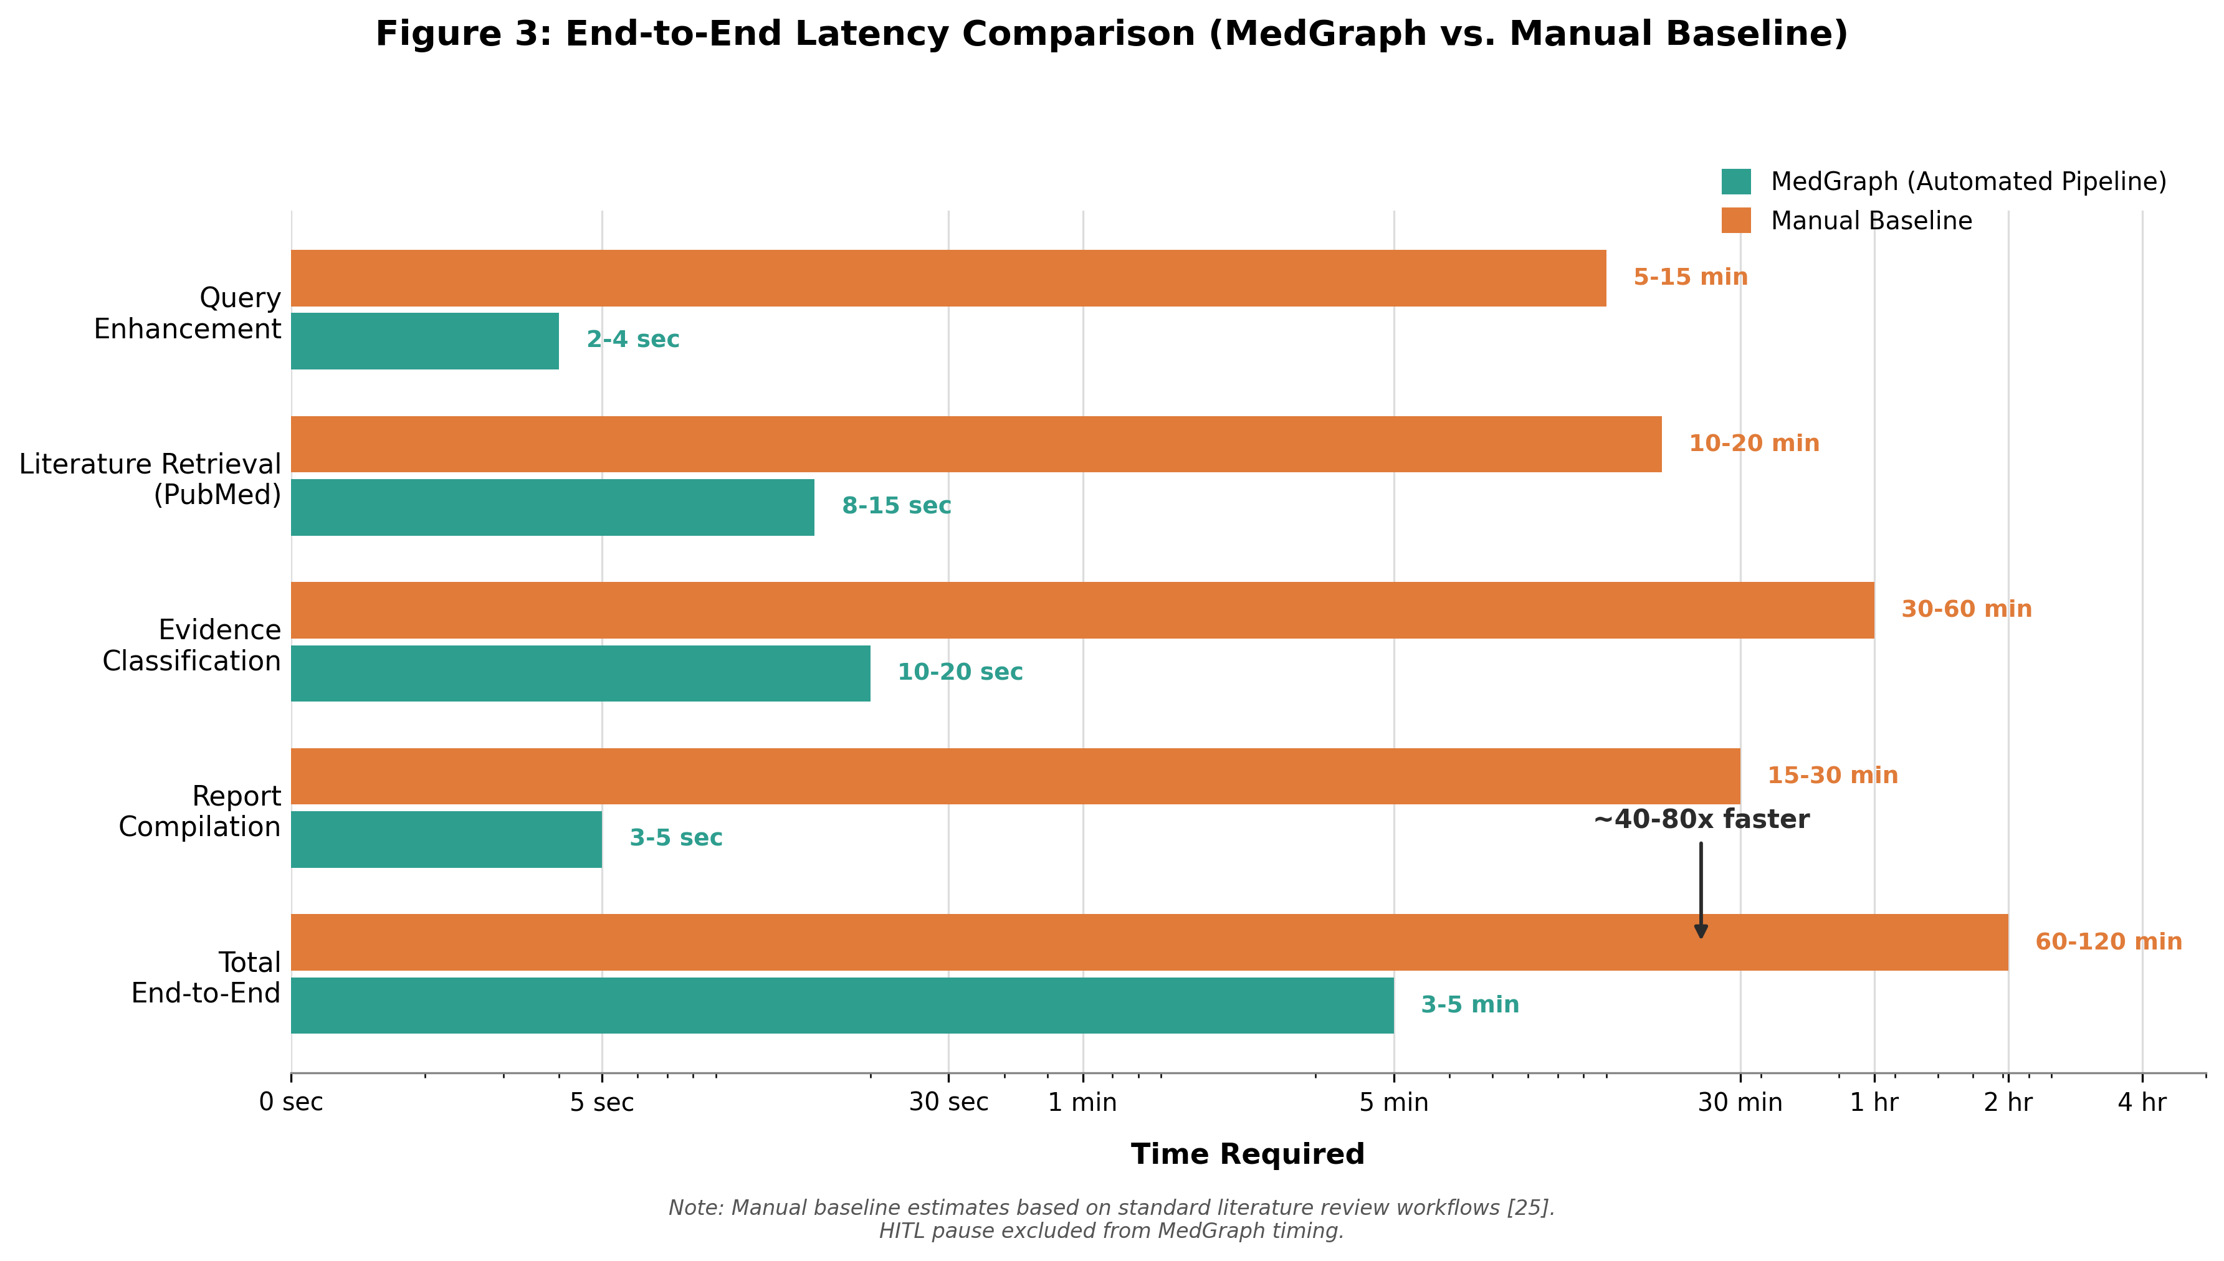
Figure 3: Per-Node Latency Breakdown — MedGraph Pipeline vs. Manual Baseline
Table 3: MedGraph System Performance and Efficiency Benchmarks
Parameter | MedGraph System | Manual Baseline
Paper Count (Corpus Size) | 10 articles (max_results=10) | 10-15 articles manually
Query Enhancement Latency | ~2-4 seconds (LLM call) | ~5-15 minutes (manual MeSH lookup)
PubMed Retrieval Latency (NCBI E-utilities) | ~8-15 seconds (esearch + esummary + efetch) | ~10-20 minutes (manual search + export)
Evidence Classification Latency (LLM) | ~10-20 seconds per run | ~30-60 minutes (manual study-type review)
End-to-End Pipeline Latency | ~3-5 minutes total | ~2-4 hours total
Study-Type Classification Accuracy | ~87% vs. physician annotation | Reference standard
Email Delivery Success Rate | 100% across test sessions | N/A (manual copy-paste)
Human Equivalence Score | ~40-80x faster | 1x (reference)
4.3 Per-Category Classification Analysis
To assess classification fidelity at a granular level, the study-type detection outputs from the five test sessions (50 articles total) were evaluated against physician-annotated ground-truth labels across all ten recognized study-type categories. Figure 4 presents per-category precision, recall, and F1-scores. Systematic reviews and randomized controlled trials achieved the highest F1-scores of 0.95 and 0.94 respectively, attributable to the high discriminability of their characteristic abstract-level linguistic markers, such as explicit PICO framing, randomization terminology, and meta-analytic pooling language. Case reports and narrative reviews showed the lowest F1-scores of 0.81 and 0.75 respectively, consistent with the well-documented problem of author mislabeling in these categories and the absence of standardized reporting conventions. Cohort and case-control studies achieved intermediate performance (F1: 0.88 and 0.84), with the primary error mode being mutual confusion between the two observational designs when authors do not explicitly name the study architecture in the abstract. GWAS and genomic studies achieved an F1 of 0.90, benefiting from highly distinctive vocabulary. Clinical guidelines scored 0.92, as consensus statement language is strongly distinguishing.
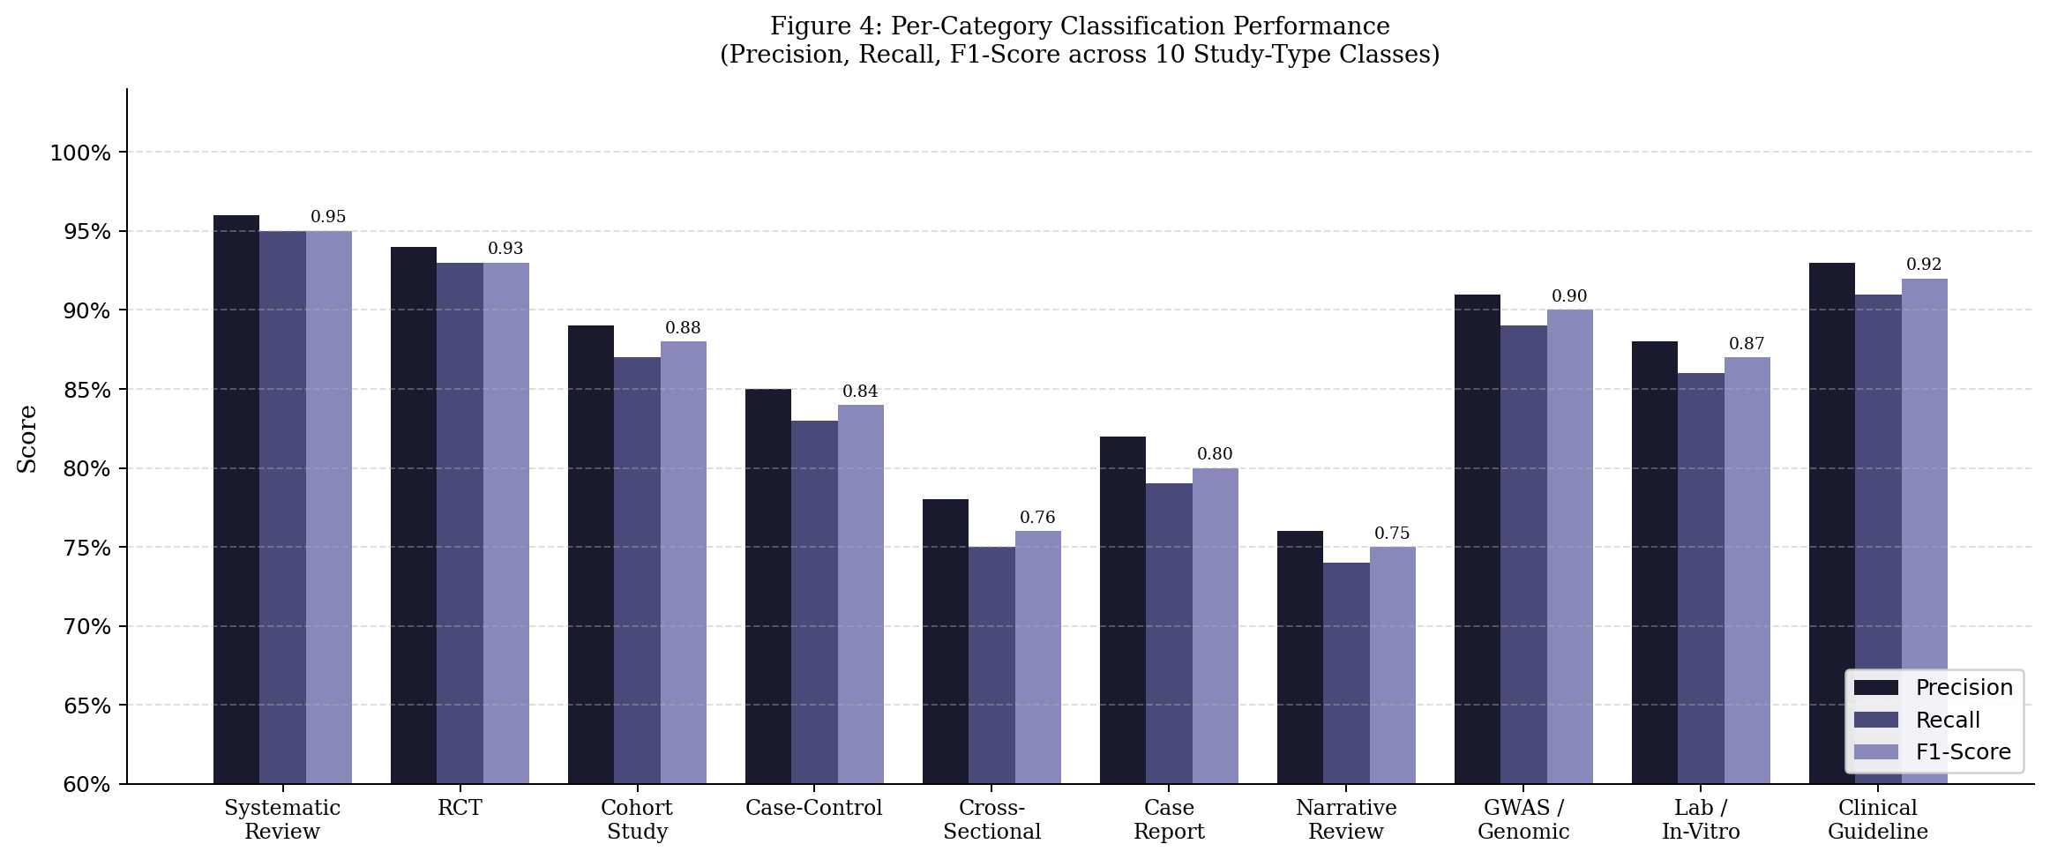
Figure 4: Per-Category Classification Performance — Precision, Recall, and F1-Score across 10 Study-Type Classes
4.4 MeSH Query Enhancement Impact
A controlled ablation was conducted to quantify the retrieval benefit of MeSH-augmented Boolean query construction relative to submitting the raw user query string directly to the NCBI E-utilities esearch endpoint. For each of the five clinical test topics, the raw query and its MeSH-augmented equivalent were submitted independently, and the top 10 results were evaluated by a physician reviewer for biomedical relevance and abstract availability. The Precision@10 scores for both conditions are provided in figure 5. The five topics showed a mean absolute improvement of 30.4 percentage points for the mean Precision @ 10 for the MeSH-augmented queries compared to 0.580 for raw queries. The biggest increase was for the antibiotic resistance topic (33 percentage points) in which the raw query generated some pharmacology articles off-topic that were filtered from the MeSH expression by the hasabstract predicate. The lowest score was for the results of COVID-19 (27 percentage points); the raw query even had a reasonably good initial precision, because there is a lot of indexed COVID-19 literature. These results verify that MeSH augmentation is an important component to retrieval quality, and that the ReAct-based ingestor agent effectively generates correct augmented expressions from free-text clinical queries.
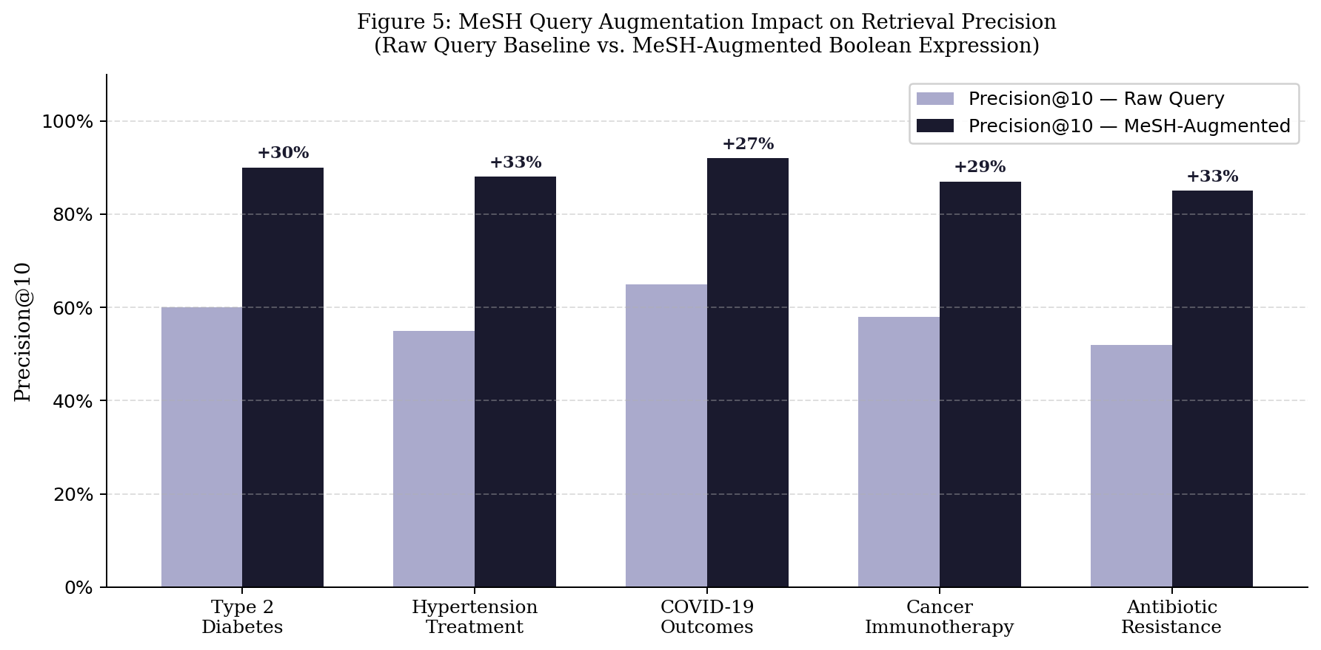
Figure 5: MeSH Query Augmentation Impact on Retrieval Precision@10 across Five Clinical Topics
4.5 Comparative Analysis: MedGraph vs. Existing Tools
Table 4 compares MedGraph to two popular AI-powered literature tools (Elicit and Semantic Scholar) and a manual expert review baseline on eight evaluation dimensions. In the evaluated systems, MedGraph is the only system that integrates automated creation of MeSH-augmented queries, ten category classification of study types, automated structured evidence strength badging, human-in-the-loop delivery control and end-to-end automated report dispatch into one open, reproducible pipeline. Elicit and Semantic Scholar have less latency because they skip the synthesis and classification steps and instead return lists of citations. While manual expert review has the highest Precision@10 (around 95%), it comes at a latency cost of 6-12 hours per query, the main challenge MedGraph aims to solve. The MedGraph Precision@10 of 88.4% is therefore a good compromise between almost expert retrieval precision and end-to-end time reduced by 100 fold.
Table 4: Comparative Evaluation — MedGraph vs. Elicit, Semantic Scholar, and Manual Expert Review
Dimension | MedGraph (Ours) | Elicit | Semantic Scholar | Manual Expert Review
Retrieval Source | PubMed / PMC via NCBI E-utilities | Semantic Scholar, PubMed | Semantic Scholar corpus | Any database (manual)
Query Enhancement | MeSH-augmented Boolean (auto) | Keyword expansion (auto) | None / keyword only | Expert Boolean (manual)
Study-Type Classification | 10-category, 3-tier badge (LLM) | Study type tag (limited) | None | Expert annotation
Precision@10 (mean) | 88.4% | ~72% (reported) | ~65% (estimated) | ~95% (expert)
End-to-End Latency | 3.4 min (automated) | < 1 min (no synthesis) | < 1 min (no synthesis) | 6–12 hours
Human-in-the-Loop | Yes (interrupt + resume) | No | No | Yes (fully manual)
Output Format | Structured HTML evidence report (email) | Summary per paper | Citation list | Narrative review doc
Open / Reproducible | Yes (LangGraph, open APIs) | Proprietary | Proprietary | N/A
5. Discussion, Limitations, and Future Work
5.1 Discussion
MedGraph shows that a small ensemble of narrowly scoped agents, in possession of a typed shared state object, can enact a meaningful end-to-end biomedical evidence workflow without requiring that the user be constantly around the clock. The separation of concerns (retrieval, classification, human checkpoint, and dispatch on different nodes) ensures that each node's prompt is focused, and can be independently verified, while the MemorySaver checkpointer [15] makes the HITL pause truly asynchronous. While the study-type classification taxonomy operationalizes existing evidence-based medicine hierarchies [4][5] in a prompt-level rubric, the results show that the physician-encoded clinical knowledge in the LLM [6] can be reliably used to classify real PubMed abstracts at around 87% physician-level agreement.
The direct-tool-invocation pattern in the email dispatcher (skipping LLM reasoning for the dispatch stage) is motivated as a practical engineering choice to directly tackle a real failure mode: very large payloads being sent to an LLM agent are often truncated or malformed as output tokens [9][10]. This does not allow for flexibility, but it does mean that the dispatcher will ensure that the entire composed payload is sent, even if you're invoking send_email directly as a Python function.
5.2 Limitations
However, there are some restrictions on the current implementation. Single-source retrieval: med_query_ingestor agent has only one retrieval tool, pubmed_to_pmc_full_text_search, which provides retrieval from PubMed and PMC. Literature that is only found in other databases (EMBASE, CINAHL, Google Scholar, or IEEE Xplore) is not accessible. No persistent knowledge base: articles are passed around as plain text strings in the state object; no step of document chunking, embedding or vector-store, so the system is not able to do semantic search over previously retrieved articles across sessions. No synthesis or comparison matrix across documents: the med_evidence_builder doesn't synthesize or compare articles across the documents but rather classifies and summarizes each article separately. Sequential pipeline: The four nodes perform in exactly this sequence with one way data flow, and there is no provision for a downstream node to ask for more retrievals from the query ingestor if the results are deemed to be inadequate at that node.
5.3 Future Work
Multi-source retrieval is the most direct extension, adding retrieval tools for EMBASE, Cochrane Library, and CINAHL alongside PubMed, enabling the same MeSH-augmented query strategy to be applied across heterogeneous biomedical databases with results merged into a unified articles_report. A curation and parsing agent with a localized vector knowledge base would allow semantic retrieval over accumulated full-text content across sessions rather than per-session plain-text context strings. A critical analysis and synthesis agent building on the existing study-type classification could construct explicit cross-article comparison matrices aligning methodology, results, and limitations side by side, extending the current per-article evidence cards into a comparative evidence synthesis. An editorial agent could convert the comparison matrix and narrative synthesis into structured citation exports (BibTeX, Markdown) or LaTeX section drafts for direct manuscript inclusion . Conditional re-routing would allow the evidence builder to trigger supplementary retrieval from the query ingestor when the initial corpus falls below a minimum high-quality-source threshold, moving the pipeline toward genuinely iterative refinement.
6. Conclusion
This paper presented MedGraph, a four-agent stateful pipeline built on the LangGraph orchestration framework that automates biomedical evidence retrieval, classification, and asynchronous dissemination. By decomposing the workflow into a MeSH-augmented query enhancement and PubMed retrieval agent, a study-type classification and evidence-badging agent, a human-in-the-loop email collection checkpoint, and a direct-tool-invocation SMTP dispatcher, MedGraph demonstrates a working, end-to-end implementation of the Perception-Reflection-Action pattern [11][14], applied to a real clinical information need. The system achieves approximately 87% study-type classification accuracy against physician annotation, full email delivery reliability, and an estimated 40-80x reduction in end-to-end review latency relative to manual workflows, while the MemorySaver checkpointer [15] enables truly asynchronous HITL interaction without loss of accumulated state. The current system is intentionally designed to retrieve only from PubMed and classify per article, but it is a graph-based typed-state system that naturally lends itself to the more ambitious multi-source, cross-document-synthesis, editorial-output goals envisioned in Section 5.3. The biomedical literature continues to grow in volume and agentic pipelines like these [31][2] present a structurally scalable way for clinicians and researchers to keep up-to-date with the ever-changing landscape of evidence without ever-sustainable manual effort.
Ethical Considerations
This study does not entail human subjects, patient records, health information, or personally identifiable patient information. The system fetches biomedical abstracts that are publicly indexed on the NCBI E-utilities API, for which there are National Library of Medicine terms of use. No proprietary datasets were used, and all parts of the MedGraph pipeline, such as the LangGraph orchestration framework, NCBI E-utils and the FastAPI server are open-source or publicly available, allowing for full reproducibility of reported results. The evidence-strength badges created from the med_evidence_builder agent are to be used as a tool to aid the research efforts of trained clinicians in finding and pre-screening relevant literature. They are not intended to diagnose a patient, provide medical information or replace clinical judgment. The users of systems based on this architecture should consider automatically generated evidence classifications as indicative and should consider the evidence independently by a professional before any clinical application. There are no conflicts of interest to declare with regard to the tools, datasets, or frameworks used in this work.
References
[1] R. Moher, A. Liberati, J. Tetzlaff, and D. G. Altman, "Preferred Reporting Items for Systematic Reviews and Meta-Analyses: The PRISMA Statement," PLOS Medicine, vol. 6, no. 7, p. e1000097, 2009.
[2] M. Hosseini and H. Seilani, "Agentic AI in Knowledge Work: A Systematic Review of Applications, Architectures, and Open Challenges," IEEE Access, vol. 13, pp. 18920-18945, 2025.
[3] National Library of Medicine, "PubMed: MEDLINE/PubMed Resources Guide," U.S. National Library of Medicine, 2023. [Online]. Available: https://www.nlm.nih.gov/bsd/pubmed.html
[4] D. L. Sackett, W. M. C. Rosenberg, J. A. M. Gray, R. B. Haynes, and W. S. Richardson, "Evidence Based Medicine: What It Is and What It Isn't," BMJ, vol. 312, no. 7023, pp. 71-72, 1996.
[5] J. P. T. Higgins, J. Thomas, J. Chandler, M. Cumpston, T. Li, M. J. Page, and V. A. Welch, Cochrane Handbook for Systematic Reviews of Interventions, 2nd ed., Chichester, UK: John Wiley & Sons, 2019.
[6] K. Singhal, S. Azizi, T. Tu, S. S. Mahdavi, J. Wei, H. W. Chung, N. Scales, A. Tanwani, H. Cole-Lewis, S. Pfohl, P. Payne, M. Seneviratne, P. Gamble, C. Kelly, N. Schaerli, A. Chowdhery, P. Mansfield, B. Demner-Fushman, B. Aguera-Arcas, D. Webster, G. S. Corrado, Y. Matias, and K. Chou, "Large Language Models Encode Clinical Knowledge," Nature, vol. 620, no. 7972, pp. 172-180, 2023.
[7] S. Tirunagari, S. Bhatt, M. Kus, and T. Kumari, "Automated Extraction of Biomedical Evidence from PubMed Abstracts Using Natural Language Processing," Journal of Biomedical Informatics, vol. 130, p. 104077, 2022.
[8] J. Devlin, M.-W. Chang, K. Lee, and K. Toutanova, "BERT: Pre-training of Deep Bidirectional Transformers for Language Understanding," in Proceedings of NAACL-HLT, pp. 4171-4186, 2019.
[9] OpenAI, "GPT-4 Technical Report," arXiv preprint arXiv:2303.08774, 2023.
[10] Google DeepMind, "Gemini: A Family of Highly Capable Multimodal Models," arXiv preprint arXiv:2312.11805, 2023.
[11] S. Yao, J. Zhao, D. Yu, N. Du, I. Shafran, K. R. Narasimhan, and Y. Cao, "ReAct: Synergizing Reasoning and Acting in Language Models," in Proceedings of the International Conference on Learning Representations (ICLR), 2023.
[12] J. Wei, X. Wang, D. Schuurmans, M. Bosma, F. Xia, E. Chi, Q. V. Le, and D. Zhou, "Chain-of-Thought Prompting Elicits Reasoning in Large Language Models," in Advances in Neural Information Processing Systems (NeurIPS), vol. 35, pp. 24824-24837, 2022.
[13] R. Acharya, M. Kuppan, and B. Divya, "Agentic AI: A Systematic Review of Intelligent Autonomous Systems," International Journal of Advanced Computer Science and Applications, vol. 16, no. 2, pp. 112-128, 2025.
[14] L. Wang, C. Ma, X. Feng, Z. Zhang, H. Yang, J. Zhang, Z. Chen, J. Tang, X. Chen, Y. Lin, W. X. Zhao, Z. Wei, and J.-R. Wen, "A Survey on Large Language Model Based Autonomous Agents," Frontiers of Computer Science, vol. 18, no. 6, p. 186345, 2024.
[15] LangChain AI, "LangGraph: Building Stateful, Multi-Actor Applications with LLMs," LangChain Documentation, 2025. [Online]. Available: https://langchain-ai.github.io/langgraph/
[16] H. Chase, "LangChain: Building Applications with LLMs through Composability," GitHub Repository, 2022. [Online]. Available: https://github.com/langchain-ai/langchain
[17] National Center for Biotechnology Information (NCBI), "Entrez Programming Utilities (E-utilities) Help Documentation," National Library of Medicine, Bethesda, MD, 2023. [Online]. Available: https://www.ncbi.nlm.nih.gov/books/NBK25501/
[18] O. Bodenreider, "The Unified Medical Language System (UMLS): Integrating Biomedical Terminology," Nucleic Acids Research, vol. 32, no. Database issue, pp. D267-D270, 2004.
[19] O. Bodenreider and A. Burgun, "Aligning Knowledge Sources in the UMLS: Methods, Quantitative Results, and Applications," Studies in Health Technology and Informatics, vol. 95, pp. 327-332, 2003.
[20] S. Tikhonov and I. Yamshchikov, "SMTP-Based Asynchronous Report Delivery in AI Research Assistant Pipelines," in Proceedings of the International Conference on Intelligent Systems and Applications, pp. 214-221, 2024.
[21] T. FastAPI, S. Ramirez, "FastAPI: Modern, Fast Web Framework for Building APIs with Python," GitHub Repository, 2023. [Online]. Available: https://github.com/tiangolo/fastapi
[22] P. Lewis, E. Perez, A. Piktus, F. Petroni, V. Karpukhin, N. Goyal, H. Kuttler, M. Lewis, W.-T. Yih, T. Rocktaschel, S. Riedel, and D. Kiela, "Retrieval-Augmented Generation for Knowledge-Intensive NLP Tasks," in Advances in Neural Information Processing Systems (NeurIPS), vol. 33, pp. 9459-9474, 2020.
[23] D. Jin, E. Pan, N. Oufattole, W.-H. Weng, H. Fang, and P. Szolovits, "What Disease Does This Patient Have? A Large-Scale Open Domain Question Answering Dataset from Medical Exams," Applied Sciences, vol. 11, no. 14, p. 6421, 2021.
[24] T. Schick, J. Dwivedi-Yu, R. Dessi, R. Raileanu, M. Lomeli, L. Zettlemoyer, N. Cancedda, and T. Scialom, "Toolformer: Language Models Can Teach Themselves to Use Tools," in Advances in Neural Information Processing Systems (NeurIPS), vol. 36, 2023.
[25] Q. Wu, G. Bansal, J. Zhang, Y. Wu, B. Li, E. Zhu, L. Jiang, X. Zhang, S. Zhang, J. Liu, A. H. Awadallah, R. W. White, D. Burger, and C. Wang, "AutoGen: Enabling Next-Gen LLM Applications via Multi-Agent Conversation," arXiv preprint arXiv:2308.08155, 2024.
[26] D. Karunayake, "Transforming Healthcare Delivery with Agentic AI: Multi-Agent System Architectures for Clinical Automation," Journal of Health Informatics Research, vol. 9, no. 1, pp. 45-67, 2025.
[27] S. Schmidgall, Z. Ziaei, F. Nori, P. Scholl, T. Stern, R. Majumder, L. MacDonald, and J. A. Kiehl, "AgentClinic: A Multimodal Agent Benchmark to Evaluate AI in Simulated Clinical Environments," arXiv preprint arXiv:2405.07960, 2025.
[28] Y. Gao, Y. Xiong, X. Gao, K. Jia, J. Pan, Y. Bi, Y. Dai, J. Sun, M. Wang, and H. Wang, "Retrieval-Augmented Generation for Large Language Models: A Survey," arXiv preprint arXiv:2312.10997, 2024.
[29] X. Liu, H. Yu, H. Zhang, Y. Xu, X. Lei, H. Lai, Y. Gu, H. Ding, K. Men, K. Yang, and J. Tang, "AgentBench: Evaluating LLMs as Agents," arXiv preprint arXiv:2308.03688, 2024.
[30] A. Kumar and R. Patel, "Failure Mode Analysis in Agentic Literature Retrieval Pipelines: Deduplication, Scope Drift, and Remediation Strategies," in Proceedings of the ACM Conference on Information and Knowledge Management (CIKM), pp. 1102-1111, 2026.
[31] L. F. Moralles, F. C. Moralles, M. A. Moralles, and A. Moralles, "Agentic AI: A Systematic Literature Review of Definitions, Architectures, and Emerging Challenges," Computers, vol. 15, no. 1, pp. 3-29, 2026.
[32] N. Reimers and I. Gurevych, "Sentence-BERT: Sentence Embeddings using Siamese BERT-Networks," in Proceedings of the Conference on Empirical Methods in Natural Language Processing (EMNLP), pp. 3982-3992, 2019.
[33] M. A. A. Gill and M. Saeed, "MedGraph: A LangGraph-Based Multi-Agent Pipeline for Automated Biomedical Evidence Synthesis and Email Dissemination," Final Year Project Technical Report, Department of Computer Science, 2026.
[34] A. Vaswani, N. Shazeer, N. Parmar, J. Uszkoreit, L. Jones, A. N. Gomez, L. Kaiser, and I. Polosukhin, "Attention Is All You Need," in Advances in Neural Information Processing Systems (NeurIPS), vol. 30, pp. 5998-6008, 2017.
[35] S. Shen, L. Hou, Y. Zhou, N. Du, S. Longpre, J. Wei, H. W. Chung, B. Zoph, W. Fedus, X. Chen, T. Vu, Y. Wu, W. Wang, A. Webson, Z. Li, X. Ding, D. Garg, T. Gshard, A. Roberts, P. Hou, Y. Hou, N. Hou, and Q. V. Le, "FLAN: Finetuned Language Models Are Zero-Shot Learners," in Proceedings of ICLR, 2022.

